Power Management Module

**Requirement and its Analysis**

1. Record the number of battery charge/discharge cycle
2. Get the overall capacity of the battery in kW
3. Find the current capacity of the battery in kW
4. Record the average of the vehicle in kW/km for the first 100 km drive in factory defined path and record the same for 1,2,3 and 4 passengers
5. Update the baseline for every 100km and estimate the running average for every 100km
6. Alert the user when there is not enough battery to complete the trip
7. Provide the user with the trip distance than can be travelled with the available battery charge

Use cases for Power Management Module

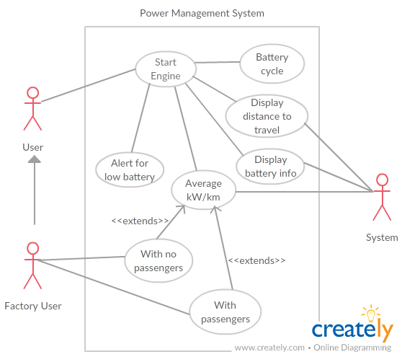

|  |  |  |
| --- | --- | --- |
| **Test Case#** | **Test Case Description** | **Expected Result** |
| TC_01 | Battery information to be displayed for the user | When the engine starts the user should be able to see the %battery consumed |
| TC_02 | Display average kW/km for the user | When the trip ends, the user should be able to see the average for every 100km run |
| TC_03 | Alert the user for low battery | Alert the user if not enough battery for the trip |
| TC_04 | Display number of charging/discharging cycles | The number of charging and discharging cycles should be displayed to the user |
| TC_05 | Calculate running average for the user | The running average for the user is calculated for every 100km |
| TC_06 | Calculate the average for the factory defined path | Average for the factory defined is to be calculated and also for all number of passengers |
| TC_07 | Alert the user if low on battery when using maps for navigation | When the user navigated through the map API, (s)he should be notified if not enough battery to complete the trip |
| TC_08 | Temperature info | Temperature of the battery has to be displayed to the user |
| TC_09 | Calculate user average for different number of passengers | The factory defined baseline has to be updated for user’s travel for different number of passengers |
| TC_10 | Display battery information on start of engine | When the engine is turned on, battery information should be displayed to the user |